**DAILY ONLINE ACTIVITIES SUMMARY**

|  |  |  |  |  |  |  |  |  |
| --- | --- | --- | --- | --- | --- | --- | --- | --- |
| **Date:** | **08/06/2020** | | | | | **Name:** | **Lavanya D M** | |
| **Sem & Sec** | **4th & ‘A’** | | | | | **USN:** | **4al18cs041** | |
| **Online Test Summary** | | | | | | | | |
| **Subject** | | **Maths** | | | | | | |
| **Max. Marks** | | **30** | | **Score** | | | **18** | |
| **Certification Course Summary** | | | | | | | | |
| **Course** | **VMware lab** | | | | | | | |
| **Certificate Provider** | | | **Bitdegree** | | **Duration** | | | **1 week** |
| **Coding Challenges** | | | | | | | | |
| **Problem Statement:1)** Write a Java Program to check whether the given matrix is magic square or not  2) C Program to Generate All the Set Partitions of n Numbers Beginning from 1 and so on | | | | | | | | |
| **Status: complied** | | | | | | | | |
| **Uploaded the report in GitHub** | | | | | **yes** | | | |
| **If yes Repository name** | | | | | <https://github.com/lavanyamurthi/lockdown-coding> | | | |
| **Uploaded the report in slack** | | | | | **yes** | | | |

Online Test Details: (Attach the snapshot and briefly write the report for the same)

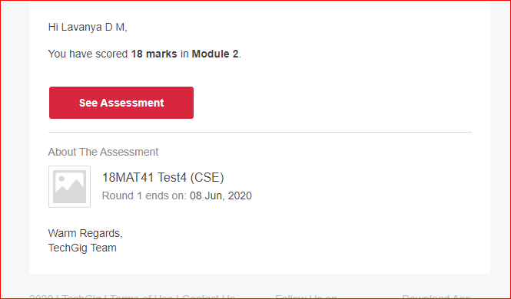

Certification Course Details: (Attach the snapshot and briefly write the report for the same)

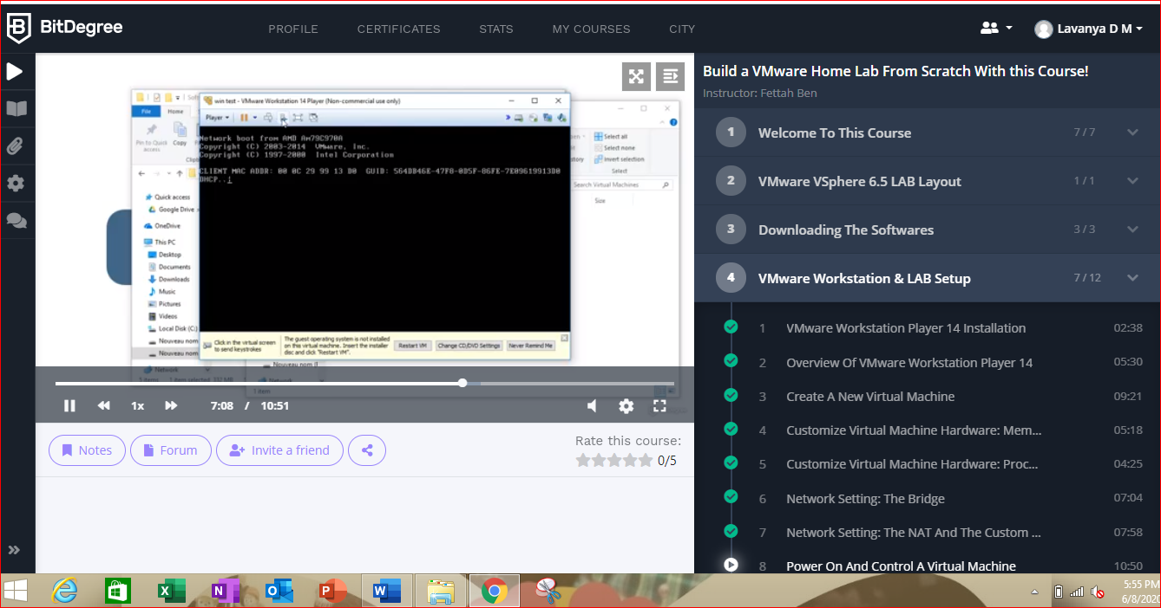

Coding Challenges Details: (Attach the snapshot and briefly write the report for the same)

Problem 1: Write a Java Program to check whether the given matrix is magic square or not

Given a matrix, check whether it’s Magic Square or not. A Magic Square is a n x n matrix of distinct element from 1 to n2 where sum of any row, column or diagonal is always equal to same number.

Examples:

Input : n = 3  
2 7 6  
9 5 1  
4 3 8  
Output : Magic matrix  
Explanation:In matrix sum of each  
row and each column and diagonals sum is  
same = 15.

Input : n = 3  
1 2 2  
2 2 1  
2 1 2  
Output : Not a Magic Matrix  
Explanation:In matrix sum of each  
row and each column and diagonals sum is  
not same.  
**Step to Follow**

1. Find sum of prime diagonal and secondary diagonal.
2. Calculate sum of each rows and columns.
3. If the prime diagonal and secondary diagonal sums is equal to every row’s sum and every column’s sum, then it is magic matrix.

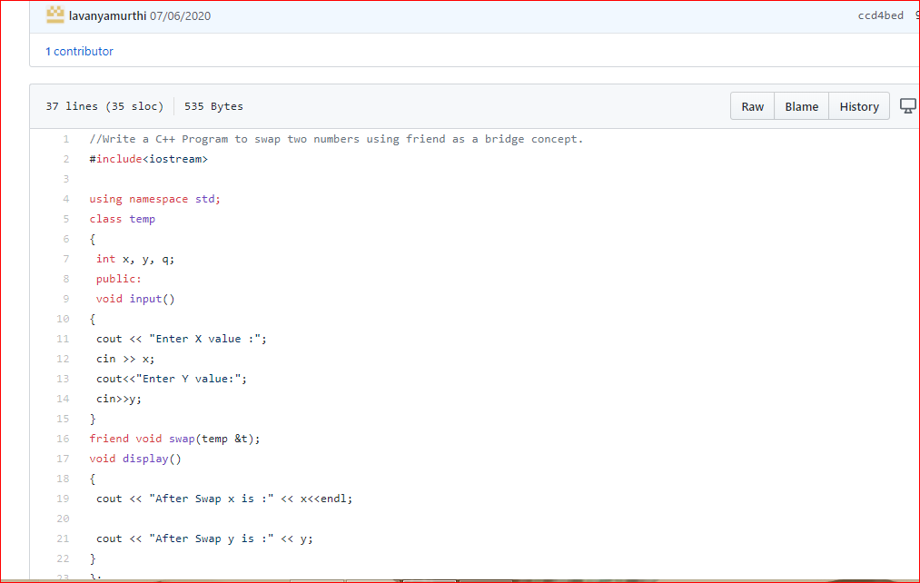

**Problem 2:** C Program to Generate All the Set Partitions of n Numbers Beginning from 1 and so on

This algorithm partitions an integer into numbers which sum up to form the original number. It generates partitions of a set of numbers for a given range.

**Sample Input**

Enter a number N to generate all set partition from 1 to N: 5  
Integer partition for 1 is:  
1

Integer partition for 2 is:  
2  
11

Integer partition for 3 is:  
3  
12  
111

Integer partition for 4 is:  
4  
13  
112  
1111  
22

Integer partition for 5 is:  
5  
14  
113  
1112  
11111  
122  
23

